Delaware Child Support System (DECSS)



DECSS UAT Database Refresh
Procedure

1 Introduction 3
2 Server, Availability Group and databases details 3
3 Refresh task resources 3-5
4 Refresh process steps in detail for ONLINE environment 5-11
5 Refresh process steps in detail for PORTAL environment 12-16
6 POST Refresh steps 16-17
7 Refresh validation 18

- Introduction

The purpose of this document is to provide information about UAT environment database refresh and steps involved during refresh procedure. Always on Availability is configured as high availability solution In UAT environment.

Extra Notes:

Setting dates

UAT Timewarp – the date should be set to date of refresh and it should NOT advance automatically

UAT Static – the date should be set to the date of refresh, and it should advance automatically.

POST-REFRESH SCRIPT EXECUTION

Please run all scripts associated with TFS work items that are in UAT Progress in both UAT Static, UAT TImewarp. This will restore the DBs to the their current status.

- Server, Availability Group and databases details

UAT server and Availability Group details.
Server Name | IP Address | Cluster/AO | SQL Connection String
dhsstsdcssc2n1 | 172.31.45.73 | 172.31.45.77 | dhsstsdcssag,15150
dhsstsdcssc2n2 | 172.31.45.74 | 172.31.45.77 | 172.31.45.77,15150
dhsstsdcssc2n3 | 172.31.45.75 | 172.31.45.78 | dhsstsdcssCPag,15150
dhsstsdcssc2n4 | 172.31.45.76 | 172.31.45.78 | 172.31.45.78,15150

Database details.
Online Availability group: dhsstsdcssag,15150
- DHSSTSDCSSC2N1\TSDCSEDB1 & DHSSTSDCSSC2N2\TSDCSEDB2
- DCSE_DECSS_TEST
- DCSE_DECSSRPT_TEST
- DCSE_DECSSTIMEWARP_TEST
- DCSE_DECSSRPTTIMEWARP_TEST

Portal Availability group: dhsstsdcssCPag,15150
- DHSSTSDCSSC2N3\TSDCSEDB3 & DHSSTSDCSSC2N4\TSDCSEDB4
- DCSE_DECSSCPORTAL_TEST
- DCSE_DECSSCPORTAL_TIMEWARP
- DCSE_DECSSEPORTAL_TEST
- DCSE_DECSSEPORTAL_TIMEWARP

- Refresh task resources

SQL Agent job is configured for database refresh task. Agent job steps are configured to generate (except replication) and execute the *.sql scripts as required or defined for the refresh.

Job scripts are in root path: [M:\DBA.DECSS.RefreshKit\]

Online Environment:
Static Online databases: DCSE_DECSS_TEST, DCSE_DECSSRPT_TEST
Job scripts path:
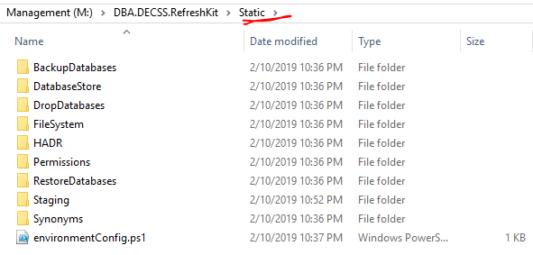

Timewarp Online databases: DCSE_DECSSTIMEWARP_TEST, DCSE_DECSSRPTTIMEWARP_TEST
Job scripts path:
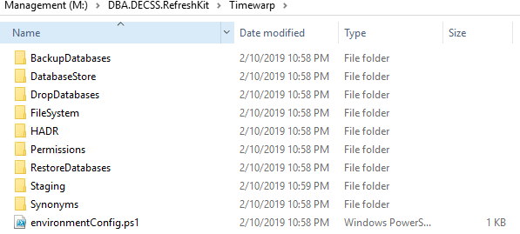

Below are the SQL Agent jobs for reference.
Online Availability group: dhsstsdcssag,15150
- DHSSTSDCSSC2N1\TSDCSEDB1 & DHSSTSDCSSC2N2\TSDCSEDB2
- DBA.DECSS.DatabaseRefresh (Static)
- DBA.DECSS.DatabaseRefresh (Timewarp)

PORTAL Environment:
Portal static databases DCSE_DECSSCPORTAL_TEST, DCSE_DECSSEPORTAL_TEST
Job scripts path:
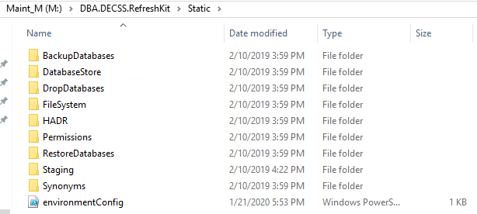

Portal Timewarp databases: DCSE_DECSSEPORTAL_TIMEWARP, DCSE_DECSSRPTTIMEWARP_TEST
Job scripts path:
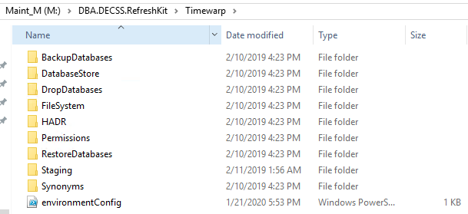

Below are the SQL Agent jobs for reference
Portal Availability group: dhsstsdcssCPag,15150
- DHSSTSDCSSC2N3\TSDCSEDB3 & DHSSTSDCSSC2N4\TSDCSEDB4
- DBA.DECSS.DatabaseRefresh (StaticPortal)
- DBA.DECSS.DatabaseRefresh (TimewarpPortal)

- Refresh steps in detail for ONLINE environment
Relevant Resources
Online Availability group: dhsstsdcssag,15150
Nodes: DHSSTSDCSSC2N1\TSDCSEDB1 & DHSSTSDCSSC2N2\TSDCSEDB2
- DCSE_DECSS_TEST
- DCSE_DECSSRPT_TEST
- DCSE_DECSSTIMEWARP_TEST
- DCSE_DECSSRPTTIMEWARP_TEST
SQL Agent Jobs
- DBA.DECSS.DatabaseRefresh (Static)
- DBA.DECSS.DatabaseRefresh (Timewarp)

I. Remove existing replication configuration:
Actions:
- Preserve replication configurations by generating Create scripts through SSMS.
- Generate script for drop replication through SSMS
- Remove/Drop Transactional replication from Test static [DCSE_DECSS_TEST] environment.
Screen shot for reference:

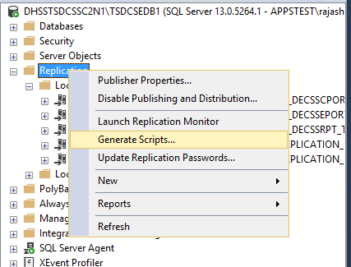

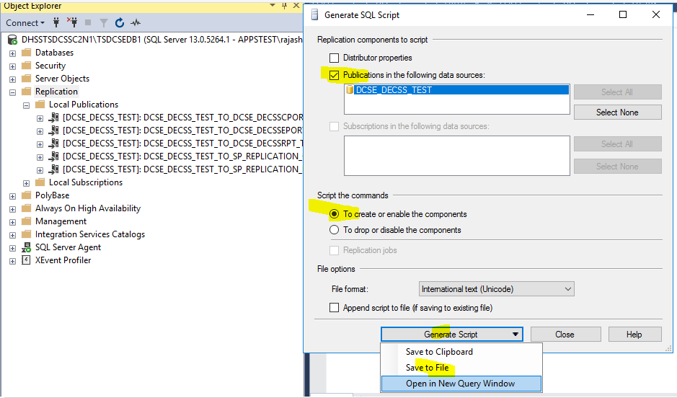
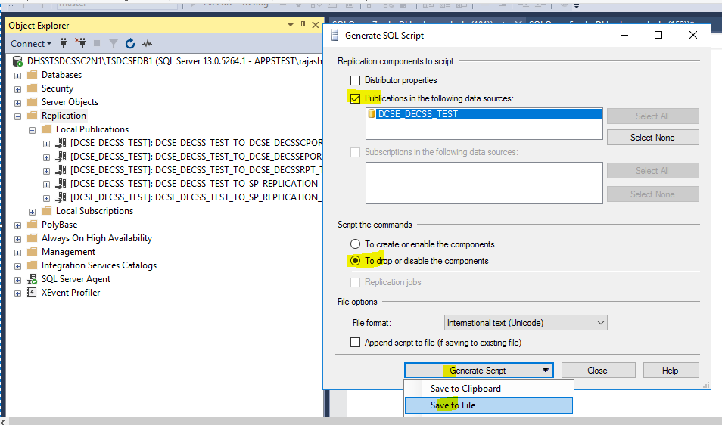

Resources: Publications details
- DHSSTSDCSSC2N1\TSDCSEDB1 $ DHSSTSDCSSC2N2\TSDCSEDB2
- [DCSE_DECSS_TEST]: DCSE_DECSS_TEST_TO_DCSE_DECSSCPORTAL_TEST
- [DCSE_DECSS_TEST]: DCSE_DECSS_TEST_TO_DCSE_DECSSEPORTAL_TEST
- [DCSE_DECSS_TEST]: DCSE_DECSS_TEST_TO_DCSE_DECSSRPT_TEST
- [DCSE_DECSS_TEST]: DCSE_DECSS_TEST_TO_SP_REPLICATION_CPORTAL
- [DCSE_DECSS_TEST]: DCSE_DECSS_TEST_TO_SP_REPLICATION_EPORTAL

II. Remove databases from Availability group
Actions:
- Remove databases from existing always on Availability group to refresh the databases.
Scripts: M:\DBA.DECSS.RefreshKit\Static\HADR\Scripts\

III. Create environment database backups
Actions:
- Backup (relevant) databases in UAT environment for future reference.
Scripts: M:\DBA.DECSS.RefreshKit\Static\BackupDatabases\Scripts\
Resources:
- dhsstsdcssag,15150
- DCSE_DECSS_TEST
- DCSE_DECSSRPT_TEST
- DCSE_DECSSTIMEWARP_TEST
- DCSE_DECSSRPTTIMEWARP_TEST

IV. Preserve User profile, role and environment tables data
Actions:
- Create temporary database (if needed) on residing database servers.
- Create temporary tables in temporary database for user profile, role and environment data.
- Copy tables from source database to temporary database.
Scripts: M:\DBA.DECSS.RefreshKit\Static\Staging\Scripts\PRE\
Resources:
- dhsstsdcssag,15150
- DCSE_DECSS_TEST
- USEM_Y1
- USRL_Y1
- UASM_Y1
- ROLE_Y1
- RLSA_Y1
- ENVG_Y1

- DCSE_DECSSTIMEWARP_TEST
- USEM_Y1
- USRL_Y1
- UASM_Y1
- ROLE_Y1
- RLSA_Y1
- ENVG_Y1
V. Generate Scripts: Preserve database users, user permissions and roles
Actions:
- Generate SQL script for creating user permissions based on current user state.
Script: M:\DBA.DECSS.RefreshKit\Static\Permissions\Scripts\Create\
Resources:
- dhsstsdcssag,15150
- DCSE_DECSS_TEST
- DCSE_DECSSRPT_TEST
- DCSE_DECSSTIMEWARP_TEST
- DCSE_DECSSRPTTIMEWARP_TEST

VI. Generate Scripts: Preserve synonyms configurations
Actions:
- Generate SQL script for the CREATE of existing (relevant) database synonyms.
Scripts: M:\DBA.DECSS.RefreshKit\Static\Synonyms\Scripts\
Resources:
- dhsstsdcssag,15150
- DCSE_DECSS_TEST
- DCSE_DECSSRPT_TEST
- DCSE_DECSSTIMEWARP_TEST
- DCSE_DECSSRPTTIMEWARP_TEST

VII. Drop Databases
Actions:
- Drop online databases from Primary and Secondary nodes as Databases are in Availability Group.
Scripts: M:\DBA.DECSS.RefreshKit\Static\DropDatabases\Scripts\
Resources:
- DHSSTSDCSSC2N1\TSDCSEDB1 & DHSSTSDCSSC2N2\TSDCSEDB2
- DCSE_DECSS_TEST
- DCSE_DECSSRPT_TEST
- DCSE_DECSSTIMEWARP_TEST
- DCSE_DECSSRPTTIMEWARP_TEST

IIX. Restore Databases
Actions:
- Restore Online and Reporting databases with (latest datetime-matching Or business team requested date) backup set from production UNC share: \\DHSSBKDB02\prdcssc1\PRDECSSAG1_BKP\Data\
Scripts: M:\DBA.DECSS.RefreshKit\Static\RestoreDatabases\Scripts\
Note:
- Backup set for DECSS is comprised of Online (DCSE_DECSS), Reporting (DCSE_DECSSRPT),
C-Portal (DCSE_DECSSCPORTAL) and E-Portal (DCSE_DECSSEPORTAL) databases.
The date/time of each of the backup files (yyyymmdd_hhmmss) are appended in the filename.
- Online and Reporting database backups can be located on production share in (\\DHSSBKDB02\prdcssc1\PRDECSSAG1_BKP\Data ).
- C-Portal and E-Portal database backups can be located on production share in (\\DHSSBKDB02\prdcssc1\PRDECSSAG2_BKP\Data ).
Resources:
- dhsstsdcssag,15150
- DCSE_DECSS_TEST
- DCSE_DECSSRPT_TEST
- DCSE_DECSSTIMEWARP_TEST
- DCSE_DECSSRPTTIMEWARP_TEST

IX. Restore Synonyms
Actions:
- Drop the existing production synonyms.
- Create the synonyms with relevant database configurations which was taken at step#6.
Scripts: M:\DBA.DECSS.RefreshKit\Static\Synonyms\Scripts\
Resources:
- dhsstsdcssag,15150
- DCSE_DECSS_TEST
- DCSE_DECSSRPT_TEST
- DCSE_DECSSTIMEWARP_TEST
- DCSE_DECSSRPTTIMEWARP_TEST

X. Restore Permissions
Actions:
- Drop existing production user base data.
- Create relevant database users and permissions by executing the SQL script generated (earlier at step#5) for Create permissions.
Scripts: M:\DBA.DECSS.RefreshKit\Static\Permissions\
Resources:
- dhsstsdcssag,15150
- DCSE_DECSS_TEST
- DCSE_DECSSRPT_TEST
- DCSE_DECSSTIMEWARP_TEST
- DCSE_DECSSRPTTIMEWARP_TEST

XI. Restore User profile, role and environment tables data
Actions:
- Adjust the differences or incremental changes for user profile tables (UASM_Y1, USEM_Y1, USRL_Y1)
Note: These changes are based on environment and as per the requirement
- Copy or adjust (INSERT) incremental data for USRL_Y1, USEM_Y1, UASM_Y1 tables from temporary tables (which was generated earlier at step#4) as per the business requirement.
- Adjust the differences for ROLE_Y1 and RLSA_Y1 as required.
- Truncate and Insert ENVG_Y1 table data from temporary database table.
Scripts: M:\DBA.DECSS.RefreshKit\Static\Staging\Scripts\POST\
Resources:
- dhsstsdcssag,15150
- DCSE_DECSS_TEST
- USEM_Y1
- USRL_Y1
- UASM_Y1
- ROLE_Y1
- RLSA_Y1
- ENVG_Y1

- DCSE_DECSSTIMEWARP_TEST
- USEM_Y1
- USRL_Y1
- UASM_Y1
- ROLE_Y1
- RLSA_Y1
- ENVG_Y1

XII. Shrink database log files
Actions:
- Shrink the databases log files.
M:\Scripts\DB_LogShrink\
Resources:
- dhsstsdcssag,15150
- DCSE_DECSS_TEST
- DCSE_DECSSRPT_TEST
- DCSE_DECSSTIMEWARP_TEST
- DCSE_DECSSRPTTIMEWARP_TEST

XIII. Checkpoint: Create (Intermediate) database backups
Actions:
- Backup (relevant) databases (Do not overwrite “Starting” database backups created earlier at step#3) for restoring on secondary nodes to join the databases in Availability Group.
Scripts: M:\DBA.DECSS.RefreshKit\Static\BackupDatabases\Scripts\*HADR.sql
Resources:
- dhsstsdcssag,15150
- DCSE_DECSS_TEST
- DCSE_DECSSRPT_TEST
- DCSE_DECSSTIMEWARP_TEST
- DCSE_DECSSRPTTIMEWARP_TEST

XIV. Restore databases on Secondary servers
Actions:
- Restore the backups taken on primary to current secondary servers.
Scripts: M:\DBA.DECSS.RefreshKit\Static\RestoreDatabases\Scripts\*HADR.sql
Resources:
- Secondary server
- DCSE_DECSS_TEST
- DCSE_DECSSRPT_TEST
- DCSE_DECSSTIMEWARP_TEST
- DCSE_DECSSRPTTIMEWARP_TEST

XV. Join the databases to Availability Group
Actions:
- Join the databases to Availability group.
Scripts: M:\DBA.DECSS.RefreshKit\Static\HADR\Scripts\Join\

- Refresh steps in detail for PORTAL environment
Relevant Resources
Portal Availability group: dhsstsdcssCPag,15150
Nodes: DHSSTSDCSSC2N3\TSDCSEDB3 & DHSSTSDCSSC2N4\TSDCSEDB4
- DCSE_DECSSCPORTAL_TEST
- DCSE_DECSSCPORTAL_TIMEWARP
- DCSE_DECSSEPORTAL_TEST
- DCSE_DECSSEPORTAL_TIMEWARP
SQL Agent Jobs:
- DBA.DECSS.DatabaseRefresh (StaticPortal)
- DBA.DECSS.DatabaseRefresh (TimewarpPortal)

I. Remove databases from Availability group
Actions:
- Remove databases from existing always on Availability group to refresh the databases.
Scripts: M:\DBA.DECSS.RefreshKit\Static\HADR\Scripts\Remove\
Resources:
- dhsstsdcssCPag,15150
- DCSE_DECSSCPORTAL_TEST
- DCSE_DECSSCPORTAL_TIMEWARP
- DCSE_DECSSEPORTAL_TEST
- DCSE_DECSSEPORTAL_TIMEWARP

II. Create environment database backups
Actions:
- Backup (relevant) databases in UAT environment for future reference.
Scripts: M:\DBA.DECSS.RefreshKit\Static\BackupDatabases\Scripts\
Resources:
- dhsstsdcssCPag,15150
- DCSE_DECSSCPORTAL_TEST
- DCSE_DECSSEPORTAL_TEST
- DCSE_DECSSCPORTAL_TIMEWARP
- DCSE_DECSSEPORTAL_TIMEWARP

III. Generate Scripts: Preserve User profile data
Actions:
- Create temporary database (if needed) on residing database servers.
- Create temporary tables in temporary database for user profile, role and environment data.
- Copy tables from source database to temporary database.
Scripts: M:\DBA.DECSS.RefreshKit\Static\Staging\Scripts\PRE\
Resources:
- dhsstsdcssCPag,15150
- DCSE_DECSSCPORTAL_TEST
  - CRCDT_Y1
  - CRUDT_Y1
- DCSE_DECSSEPORTAL_TEST
- MRUDT_Y1

- DCSE_DECSSCPORTAL_TIMEWARP
- CRCDT_Y1
- CRUDT_Y1
- DCSE_DECSSEPORTAL_TIMEWARP
- MRUDT_Y1

IV. Generate Scripts: Preserve database users, user permissions and roles
Actions:
- Generate SQL script for creating user permissions based on current user state.
Script: M:\DBA.DECSS.RefreshKit\Static\Permissions\Scripts\Create\
Resources:
- dhsstsdcssCPag,15150
- DCSE_DECSSCPORTAL_TEST
- DCSE_DECSSEPORTAL_TEST
- DCSE_DECSSCPORTAL_TIMEWARP
- DCSE_DECSSEPORTAL_TIMEWARP

V. Generate Scripts: Preserve Synonyms configurations
Actions:
- Generate SQL script for the CREATE of existing (relevant) database synonyms.
Scripts: M:\DBA.DECSS.RefreshKit\Static\Synonyms\Scripts\
Resources:
- dhsstsdcssCPag,15150
- DCSE_DECSSCPORTAL_TEST
- DCSE_DECSSEPORTAL_TEST
- DCSE_DECSSCPORTAL_TIMEWARP
- DCSE_DECSSEPORTAL_TIMEWARP

VI. Drop Databases
Actions:
- Drop portal databases in Primary and Secondary nodes as databases are in Availability Group.
Scripts: M:\DBA.DECSS.RefreshKit\Static\DropDatabases\Scripts\
Resources:
- DHSSTSDCSSC2N3\TSDCSEDB3 & DHSSTSDCSSC2N4\TSDCSEDB4
- DCSE_DECSSCPORTAL_TEST
- DCSE_DECSSEPORTAL_TEST
- DCSE_DECSSCPORTAL_TIMEWARP
- DCSE_DECSSEPORTAL_TIMEWARP

VII. Restore Databases
Actions:
- Restore C-Portal and E-Portal databases with (latest datetime-matching Or business team requested date) backup set from production UNC share: \\DHSSBKDB02\prdcssc1\PRDECSSAG2_BKP\Data\
Scripts: M:\DBA.DECSS.RefreshKit\Static\RestoreDatabases\Scripts\
Note:
- Backup set for DECSS is comprised of Online (DCSE_DECSS), Reporting (DCSE_DECSSRPT),
C-Portal (DCSE_DECSSCPORTAL) and E-Portal (DCSE_DECSSEPORTAL) databases.
The date/time of each of the backup files (yyyymmdd_hhmmss) are appended in the filename.
- Online and Reporting database backups can be located on production share in (\\DHSSBKDB02\prdcssc1\PRDECSSAG1_BKP\Data ).
- C-Portal and E-Portal database backups can be located on production share in (\\DHSSBKDB02\prdcssc1\PRDECSSAG2_BKP\Data ).
Resources:
- dhsstsdcssCPag,15150
- DCSE_DECSSCPORTAL_TEST
- DCSE_DECSSEPORTAL_TEST
- DCSE_DECSSCPORTAL_TIMEWARP
- DCSE_DECSSEPORTAL_TIMEWARP

IIX. Restore Synonyms
Actions:
- Drop the existing production synonyms.
- Create the synonyms with relevant database configurations which was taken at step#5.
Scripts: M:\DBA.DECSS.RefreshKit\Static\Synonyms\Scripts\
Resources:
- dhsstsdcssCPag,15150
- DCSE_DECSSCPORTAL_TEST
- DCSE_DECSSEPORTAL_TEST
- DCSE_DECSSCPORTAL_TIMEWARP
- DCSE_DECSSEPORTAL_TIMEWARP

IX. Restore Permissions
Actions:
- Drop existing production user base data.
- Create relevant database users and permissions by executing the SQL script generated (earlier at step#4) for Create permissions.
Scripts: M:\DBA.DECSS.RefreshKit\Static\Permissions\
Resources:
- dhsstsdcssCPag,15150
- DCSE_DECSSCPORTAL_TEST
- DCSE_DECSSEPORTAL_TEST
- DCSE_DECSSCPORTAL_TIMEWARP
- DCSE_DECSSEPORTAL_TIMEWARP

X. Checkpoint: Create (Intermediate) database backups
Actions:
- Backup (relevant) databases (Do not overwrite “Starting” database backups created earlier at step#2) for restoring on secondary nodes to join the databases in Availability Group.
Scripts: M:\DBA.DECSS.RefreshKit\Static\BackupDatabases\Scripts\
Resources:
- dhsstsdcssCPag,15150
- DCSE_DECSSCPORTAL_TEST
- DCSE_DECSSEPORTAL_TEST
- DCSE_DECSSCPORTAL_TIMEWARP
- DCSE_DECSSEPORTAL_TIMEWARP

XI. Restore databases on Secondary servers
Actions:
- Need to restore the backups taken on primary to current secondary servers.
Scripts: M:\DBA.DECSS.RefreshKit\Static\RestoreDatabases\Scripts\
- Secondary Server
- DCSE_DECSSCPORTAL_TEST
- DCSE_DECSSEPORTAL_TEST
- DCSE_DECSSCPORTAL_TIMEWARP
- DCSE_DECSSEPORTAL_TIMEWARP

XII. Join the databases to Availability Group
Actions:
Join the databases to Availability group.
Scripts: M:\DBA.DECSS.RefreshKit\Static\HADR\Scripts

- Post restore steps:
1. Find and execute Intermediate work Item build scripts (TFS scripts compare)
Actions:
- Compare UAT scripts (to check which already moved to the environment but not to production) with PROD scripts in TFS and fetch the scripts from TFS.
- Deploy the scripts.
Resources:
- dhsstsdcssag,15150
- DCSE_DECSS_TEST
- DCSE_DECSSRPT_TEST
- DCSE_DECSSTIMEWARP_TEST
- DCSE_DECSSRPTTIMEWARP_TEST

- dhsstsdcssCPag,15150
- DCSE_DECSSCPORTAL_TEST
- DCSE_DECSSCPORTAL_TIMEWARP
- DCSE_DECSSEPORTAL_TEST
- DCSE_DECSSEPORTAL_TIMEWARP

2. Configure Transactional Replication
Actions:
- Configure the replication by using initially created CREATE script.
Resources:
- dhsstsdcssag,15150
- DCSE_DECSS_TEST
- DCSE_DECSSRPT_TEST
- dhsstsdcssCPag,15150
- DCSE_DECSSCPORTAL_TEST
- DCSE_DECSSEPORTAL_TEST
- dhsstsdcssag,15150
- [DCSE_DECSS_TEST]: DCSE_DECSS_TEST_TO_DCSE_DECSSCPORTAL_TEST
- [DCSE_DECSS_TEST]: DCSE_DECSS_TEST_TO_DCSE_DECSSEPORTAL_TEST
- [DCSE_DECSS_TEST]: DCSE_DECSS_TEST_TO_DCSE_DECSSRPT_TEST
- [DCSE_DECSS_TEST]: DCSE_DECSS_TEST_TO_SP_REPLICATION_CPORTAL
- [DCSE_DECSS_TEST]: DCSE_DECSS_TEST_TO_SP_REPLICATION_EPORTAL

3. Set Timewarp environment date

Actions:
- Update RUN_DATE in PARM_Y1 table.
UPDATE PARM_Y1 SET Run_DATE = '' WHERE Job_ID IN ('DAILY') AND EndValidity_DATE = '9999-12-31'
- Update the System date by substituting desired date in date placeholder in below function.
- Execute SQL on (relevant) database.
ALTER FUNCTION [dbo].[BATCH_COMMON_SCALAR$SF_SYS_DATE_TIME](
)
RETURNS DATETIME2
AS
BEGIN
RETURN 'MM/DD/YYYY';
End
Resources:
- dhsstsdcssag,15150
- DCSE_DECSSTIMEWARP_TEST
- DCSE_DECSSRPTTIMEWARP_TEST

- Refresh validation
Verify the respective folders based on the job steps to read the logs and troubleshoot the refresh issues if any.

